PMS.NEXOSALExx Quick User Guide
by philippemp31@outlook.com (04/02/2022)

Table des matières
1. What is PMS.NEXOSALE 1
2. Prepare settings 2
2.1. Minimum settings 2
2.2. Advanced settings 3
3. Make a purchase 5
3.1. Stop processing 6
4. Any other service 8
5. Implement PMS.NEXOSALE 8
5.1. In a .NET project 8
5.1.1. VB 8
5.1.2. C# 9
5.2. Using a non .NET language 11
5.2.1. Delphi 11

What is PMS.NEXOSALE
PMS.NEXOSALExx is a software based on PMS.NEXOxx libraries.
PMS.NEXOxx libraries provide an implementation of nexo Retailer embedding all messages and the ability to use them. PMS.NEXOxx currently exists in 2 versions PMS.NEXO30 (nexo Retailer v3.0) and PMS.NEXO31 (nexo Retailer v3.1). PMS.NEXOSALExx also exists based on these libraries an PMS.NEXOSALE30 for nexo Retailer v3.0 and PMS.NEXOSALE31 for nexo Retailer v3.1. Before using either PMS.NEXOxx or PMS.NEXOSALExx libraries, refer to your POI supported nexo version.
PMS.NEXOSALExx apart form embedding PMS.NEXOxx and all its functionalities, also provides a complete and easy to use nexo Retailer implementation directly inside a sale system. Integration includes:
- Full settings management including:
  - Specify 2 different POI (primary and backup) with the ability to switch from one to the other
  - Specify all mandatory data to log to a POI
  - Activity tracing
- Full nexo Retailer message processing including:
  - Login & Logout
  - Payment, refund and reversal
  - Reconciliation,…
  - Exchanges with the POI and simple result management
All these functionalities are available directly within dialog windows which will take care of all user interactions, as described here after.

Prepare settings

Minimum settings
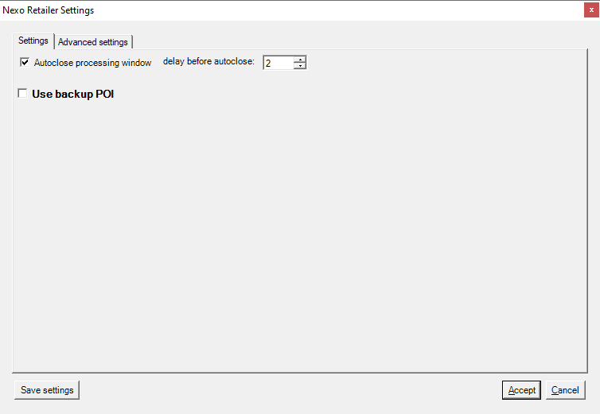
1
2
3
PMS.NEXOSALExx Minimum settings window
- Auto close processing window
This flag allows specifying whether the transaction window (showing transaction progress) must be dismissed automatically when the transaction is finished, or not.
Checking this flag will make the window disappear automatically, unchecking it will force the merchant to manually and explicitly close the window when the transaction is finished.
- Delay before auto close
If the Terminal port flag has been set (checked), this value indicates the delay (in seconds) between the end of the transaction and the moment the window is automatically closed.
A low value might make the window disappear too fast, not giving the opportunity to the merchant to really check the transaction result.
A high value makes the window to stay longer on the screen preventing the receipt to be printed.
The advised value is between 1 and 5 seconds (2 preferable).
- Use backup POI
Indicates whether the Y2 system must use the backup POI instead of the nominal one.
This is useful if the nominal POI is not reachable.
Terminal connection is available in the.

Advanced settings
The advanced setup are available if requested when displaying the settings and should be . It is strongly advised to not provide advanced setup to regular users.
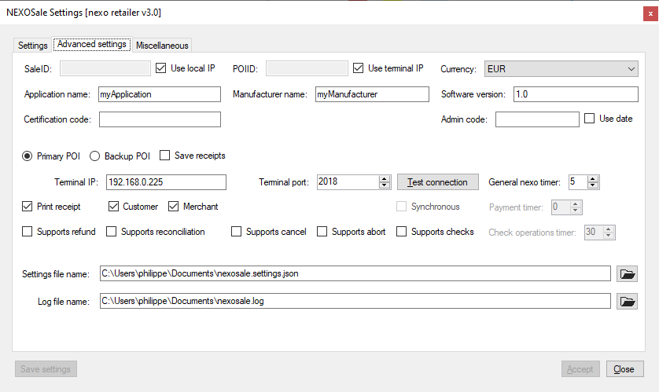
7
14
15
16
17
18
19
21
20
12
13
1
2
3
4
5
6
8
9
10
11
PMS.NEXOSALExx Advanced settings window
- SaleID
Enter any ID identifying the sale.
To easily identify the sale it is possible to let the system use the IP address making it unique on the network.
- POIID
Enter any ID identifying the POI (the terminal).
To easily identify the terminal it is possible to let the system use the IP address making it unique on the network.
- Currency
Choose the currency that will be used to perform the transactions.
- Application name
Any string identifying the application on the Y2 system.
- Manufacturer name
Any string identifying the application manufacturer on the Y2 system.
- Software version
Any string identifying the software version on the Y2 system.
- Certification code
Any string accepted by the terminal.
- Admin code
In case the terminal does not respond to a teller request, a code s requested to unlock the system. That code can be entered here. If no code is provided a date will be requested for that operation.
- Primary POI / Backup POI
Allows indicating which POI settings to display and manipulate.
- Terminal IP
The IP of the terminal to reach to perform a transaction (depends on Primary POI / Backup POI).
- Terminal port
This IP port to reach on the terminal (depends on Primary POI / Backup POI).
- Test connection
Allows to test the connection to the specified POI using the indicated IP + port data.
- General nexo timer
The timer to wait for when a non blocking operation is in progress (login, logout,…).
The advised value is between 15 seconds.
- Print receipt
Allows indicating the Y2 system must print the transaction receipt when finished.
If checked it is possible to indicate which receipts are to be printed (merchant and/or customer).
- Supports refund
Indicates if the terminal accepts to perform refunds.
- Supports reconciliation
Indicates if the terminal accepts to perform reconciliation.
- Supports abort
Indicates if the terminal accepts to perform abort.
- Supports cancel
Indicates if the terminal accepts to perform cancellation (reversal).
- Supports checks
Indicates if the terminal accepts to perform checks operations.
- Settings file name
Allows indicating where the settings file is stored. It can be stored locally or on a network.
- Log file name
Allows indicating where the log file is stored. It can be stored locally or on a network.

Make a purchase
- The merchant enters or compute the amount to pay for and calls the PMS.NEXOSALExx payment procedure (the procedure for calling this functionality might vary on cash registers).
- The amount is sent to the POI for processing.
- Once the transaction has been initiated onto the POI the purchase processing window is displayed.
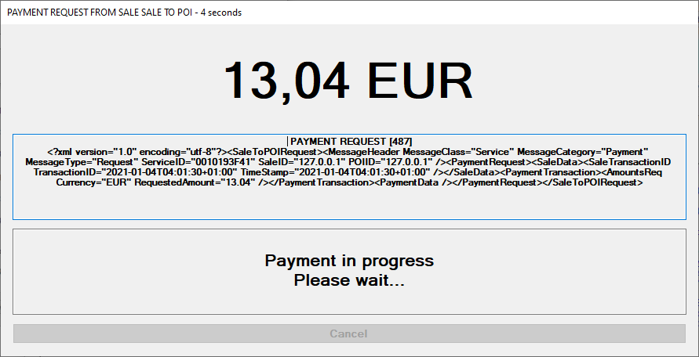
b
a
c
Purchase processing window: purchase in progress
  - AMOUNT
This upper part displays the amount of the transaction along with the transaction currency.
  - INFORMATION
The middle part displays information about how the transaction is being performed.
  - MESSAGE/RESULT
The lowest part displays messages to the merchant and the result of the transaction.

- When the transaction is completed (accepted or not) the RESULT part indicates it with a colour code and a message indicating the final result.
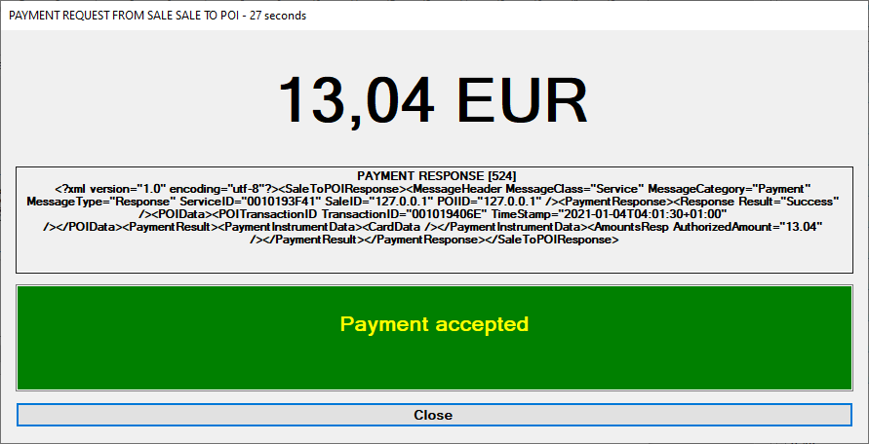
This transaction has been accepted (RESULT is GREEN)

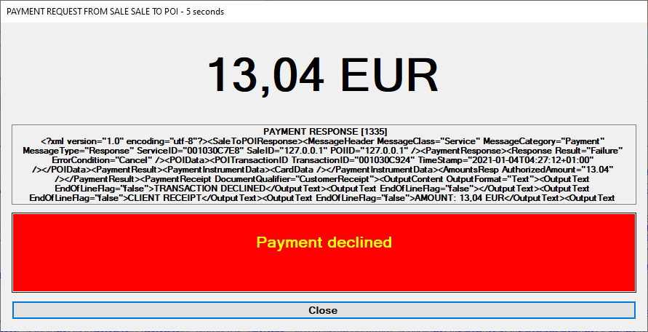
This transaction has been declined (RESULT is RED)
Please note that cancelling the transaction using the “Cancel” button will also decline the transaction (RESULT is RED) with a different message indicating the transaction was cancelled.

Stop processing
In case the terminal does not answer the sale system is blocked. In that case it is possible to unlock it by doing as follow:
- Double-click on “AMOUNT” part.
- Double-click on “INFORMATION” part.
- Double-click on “MESSAGE/RESULT” part.
That will display a window which will allow cancelling the current processing.
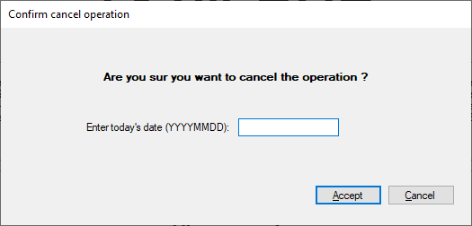
Window to cancel processing in progress
The operator must then enter either (i) the Admin code If defined or (ii) the current date in the indicated format (YYYYMMDD), then validate (entering the date has no effect if an admin code has been defined).
- If a valid admin code or date has been entered the transaction is aborted and the sale system is released.
Beware, aborting the transaction that way does not abort the transaction on the POI. The operator must use that option only in specific cases (terminal does not answer, no more network,…).

Any other service
Windows will be as for a purchase but according to the requested service (Refund, Abort,...).

Implement PMS.NEXOSALE

In a .NET project
PMS.NEXOSALExx is available for downloading in https://www.nuget.org.
To import it inside your own .NET project, inside Visual Studio:
- Right click on your project and select “Manage nuget pachages…” and make sure to use “nuget.org” as a source.
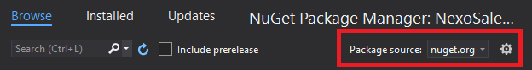
- In the Browse pane, enter “pms.nexosale” in the search widget
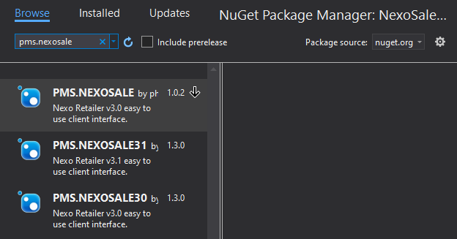
That will display all PMS.NEXOSALExx packages available.
Forget PMS.NEXOSALE which has been deprecated and select the one you want to use (PMS.NEXOSALE30 for nexo Retailer v3.0, PMS.NEXOSALE31 for nexo Retailer v3.1).

VB
- Create the object
Imports NEXOSALE
Private Nxo As New NEXOSALE.NEXOSALE
- Display the settings window
Nxo.DisplaySettings(trueOrfalse)
with trueOrfalse is:
- true: display Advanced settings
- false: Advanced settings are not made available
- Display the processing window
Public Enum Action
_none
_begin
Login
Logout
Payment
_base
Refund
Reversal
Reconciliation
Abort
_checks
ReadCheck
PrintCheck
_end
End Enum
Dim operation as Action = Action.Payment
Dim result As ActionResult = Nxo.DisplayProcessing(operation)
lblResult.Text = result.ToString
lblBrand.Text = Nxo.Brand
Select Case result
Case ActionResult.success
Select Case ComboBox1.SelectedItem
Case Action.Payment
Nxo.OriginalPOITransactionID = Nxo.POITransactionID
Nxo.OriginalPOITransactionTimestamp = Nxo.POITransactionTimestamp
Case Action.Refund
Nxo.OriginalPOITransactionID = "AAA" 'Nothing
Nxo.OriginalPOITransactionTimestamp = Nothing
Case Action.Reversal
Nxo.OriginalPOITransactionID = Nothing
Nxo.OriginalPOITransactionTimestamp = Nothing
Case Action.Reconciliation
End Select
End Select

C#
- Create the object
using NEXOSALE;
NEXOSALE Nxo = new NEXOSALE();
- Display the settings window
Nxo.DisplaySettings(trueOrfalse);
with trueOrfalse is:
- true: display Advanced settings
- false: Advanced settings are not made available
- Display the processing window
Action operation = Action.Payment;
ActionResult result = Nxo.DisplayProcessing(operation);
lblResult.Text = result.ToString();
lblBrand.Text = Nxo.Brand;
switch (result)
{
case ActionResult.success:
switch (operation)
{
case Action.Payment:
Nxo.OriginalPOITransactionID = Nxo.POITransactionID;
Nxo.OriginalPOITransactionTimestamp = Nxo.POITransactionTimestamp;
break;
case Action.Refund:
Nxo.OriginalPOITransactionID = "AAA";
Nxo.OriginalPOITransactionTimestamp = null;
break;
case Action.Reversal:
Nxo.OriginalPOITransactionID = null;
Nxo.OriginalPOITransactionTimestamp = null;
break;
case Action.Reconciliation:
break;
}
break;
}

Using a non .NET language
The component is available as a COM object for non .NET languages (Delphi,…).
To use in Delphi the component must be registered on the computer (PMS.COMMON.dll, PMS.NEXOxx.dll & PMS.NEXOSALExx.dll) using the following command:
Regasm.exe <dll to register> /codebase

Delphi
To use the component inside Delphi:
- In the menu, select: “Component→Import component”, then choose “Import a type library” and click “Next”
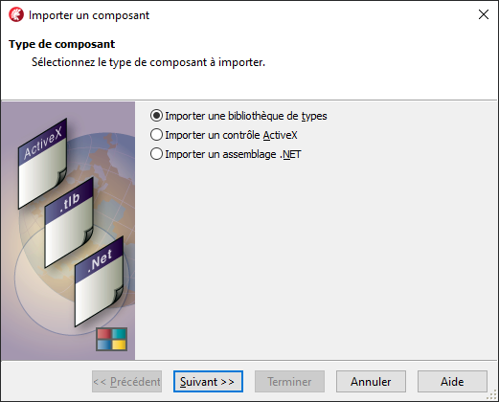
- Select the right type library to import:
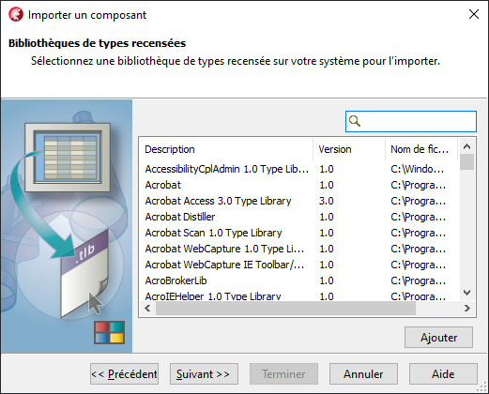
Type “client nexo retailer”
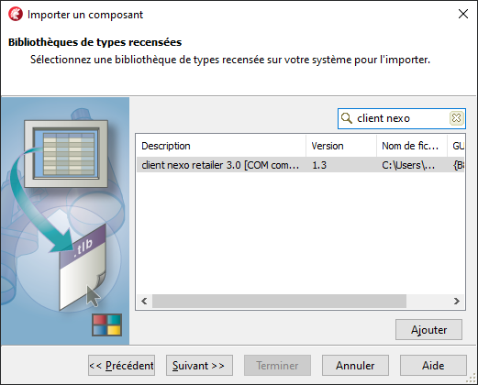
The nexo Retailer component is displayed, select it and click on “Next”
- Select where to put the the component and click on “Next”
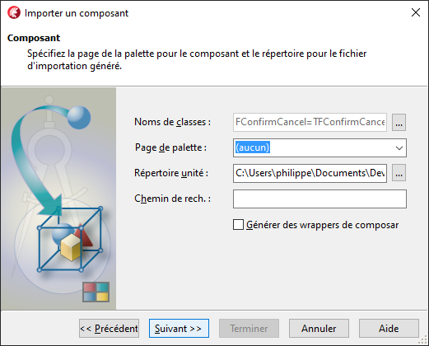
- Select “Create a unit” and click “Terminate”
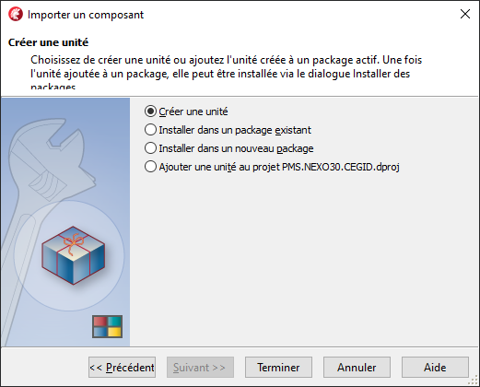
- That will create a set of units you must add to your project.
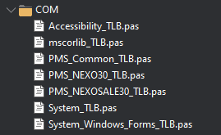
- Now go somewhere in your app and put the following statements:
// create the PMS.NEXOSALE object
myNexo := CoNEXOSale.create;
// associate your main form to the object (to prevent window disappearing)
myNexo.MainWindow := Application.MainFormHandle;
…
// call settings window (fFullSettinigs = true to display Advanced settings)
myNexo.DisplaySettings(fFullSettings);
…
// make a purchase
// set amount as expected
myNexo.amount := 100; // always expressed in cents
// set some specific settings
myNexo.MerchantReferenceID := “MYREF”;
myNexo.Login.RequestOperatorID := “MY NAME”;
…
dlgp := Action_payment;
dlgpres := myNexo.DisplayProcessing(dlgp);

// test transaction result
case dlgpres of
ActionResult_success:
begin
processedAmount := myNexo.Payment.ReplyAuthorizedAmount;
txnBrand := myNexo.Brand;
txnAuthNumber := myNexo.Payment.ReplyData.PaymentResult.PaymentAcquirerData.ApprovalCode;
if myNexo.Payment.ReplyData.PaymentResult.OnlineFlag then
txnMode := TXN_MODE_ONLINE
else
txnMode := TXN_MODE_OFFLINE;
txnCard := myNexo.Payment.ReplyData.PaymentResult.PaymentInstrumentData.CardData.MaskedPAN;
end;
else
begin
processedAmount := myNexo.Payment.RequestRequestedAmount;
case dlgpres of
ActionResult_decline:
begin
// payment has been declined
dlgpresText := TXN_RESULT_DECLINED;
end;
ActionResult_incomplete:
begin
// payment is incomplete (has been stopped)
dlgpresText := TXN_RESULT_INCOMPLETE;
end;
ActionResult_cancel:
begin
// cancelled by user while processing
dlgpresText := TXN_RESULT_CANCELLED_BY_USER;
end;
ActionResult_timeout:
begin
// timeout waiting the answer
dlgpresText := TXN_RESULT_TIMEOUT;
end;
ActionResult_exception:
begin
// an exception has occurred
dlgpresText := TXN_RESULT_EXCEPTION;
end
else
begin
dlgpresText := TXN_RESULT_UNKNOWN_ERROR;
end;
end;
end;
end;
- And you’re all set !

